

***APTECH LEARNING***

***SFC***

***E-PROJECT***



**FACULTY: Miss Kinza khan**

|  |  |  |  |
| --- | --- | --- | --- |
| **#** | **NAME** | **STUDENT ID** | **WORK** |
| **1** | **Muhammad Muneeb** | **1445532** | **Admin-panel** |
| **2** | **Abdur-Rehman** | **1447192** | **Agent - work** |
| **3** | **Muhammad Ali Ibad** | **1444201** | **User - work** |
| **4** | **Muhammad Ali Hadi** | **1444203** | **Tracking location** |
| **5** | **Yasir Hussain Hashmi** | **1444200** | **View status** |





***Courier Management System***

**Table of Contents**

**Introduction ……………………………………………………………………………...02**

**Proposed Scenario …………………………………………………………………….02**

**System Module ………………………………………………………………………….03**

**Module Description ……………………………………………………………………04**

# Introduction:

**Courier management system is currently handled manually by the organization and facing various**

**challenges in maintaining records and providing information to it’s customers. Tracking and handling**

**of couriers is becoming tedious for the organization.**

## Proposed Solution:

**Courier management system is a management software designed by considering various factors in courier billing system.**

**The proposed web app will help to manage customer information, package details, generate reports, app billing.**

**Courier management web application will be a comprehensive and complete application will be able to manage all its operations and also the tracking and manage delivery info all registered consignments or packages, manage customer related information.**

**The web app provides necessary info of status. Admin will update the details of both sender and receiver include status of booked package or consignment. User can track the courier through online site.**

### **System Modules:**

* **Admin**
* **Login**
* **New courier**
* **View all courier details**
* **Send SMS – From to**
* **Send delivery SMS**
* **Update/ delete courier**
* **Create agent**
* **Manage agent**
* **Manage customer details**
* **Status count**
* **Download report for shipment**

#### **Agent:**

* **Login**
* **New courier**
* **View all courier details**
* **Send SMS From to**
* **Send delivery SMS**
* **Status of branch**
* **Download report from branch**

##### **User:**

* **Register**
* **Login**
* **Track consignment number**
* **View status**
* **Print status**

###### Problem Statement:

**Problem statement is attached separately in a file “Courier Management System” Standards plan. Every code block must have comments. The logic of the program needs to be explained. Proper documentation should be maintained. Complete Project Report along with synopsis, code and documentation should be prepared.**

Documentation:

**Documentation comprises of the following documents:**

* **Certificate of Completion.**
* **Table of Contents.**
* **Problem Definition.**
* **Customer Requirement Specification.**
* **Project Plan.**
* **E-R Diagrams.**
* **Algorithms.**
* **GUI Standards Document.**
* **Interface Design Document.Task Sheet.**
* **Project Review and Monitoring Report.**
* **Unit Testing Check List.**
* **Final Check List.**

**Index.php**

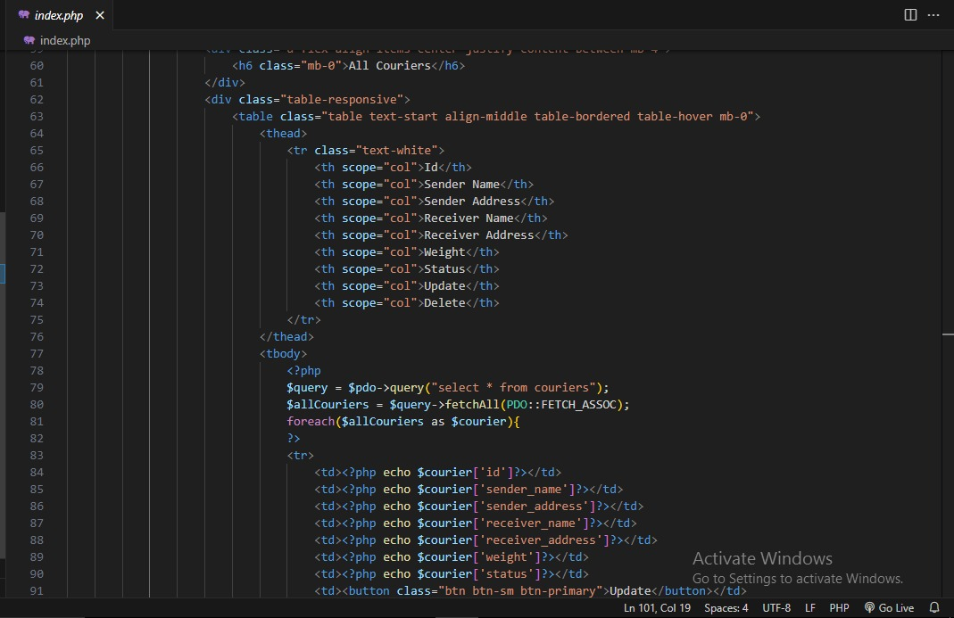

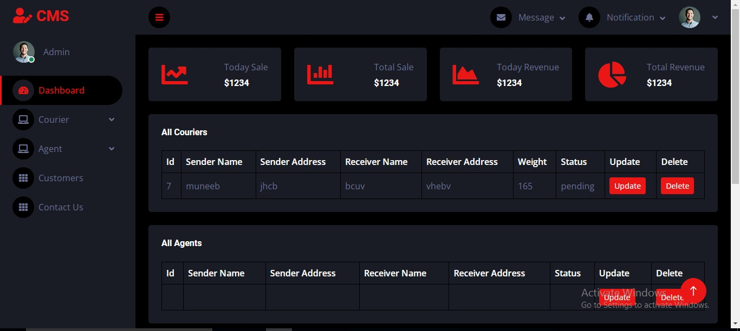

**Singin.php**

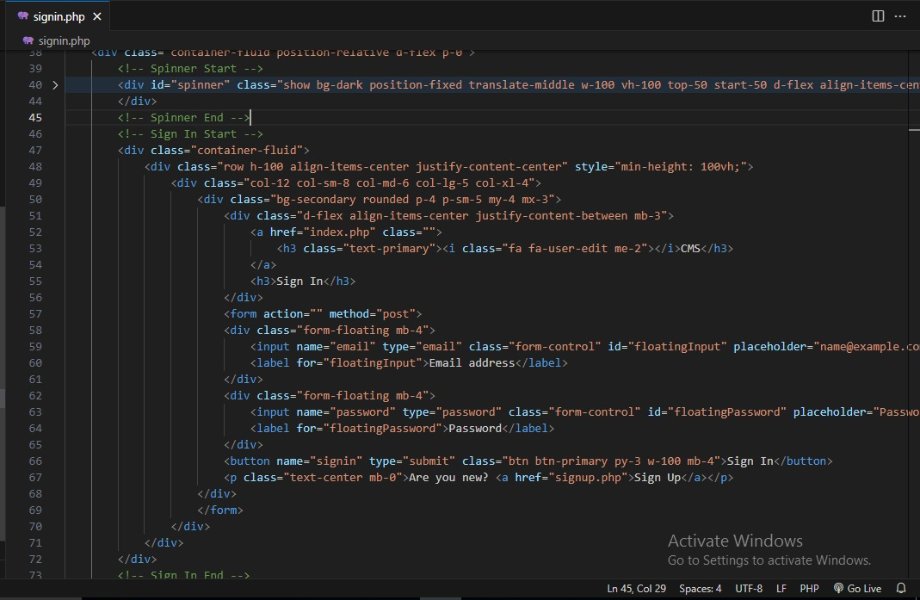

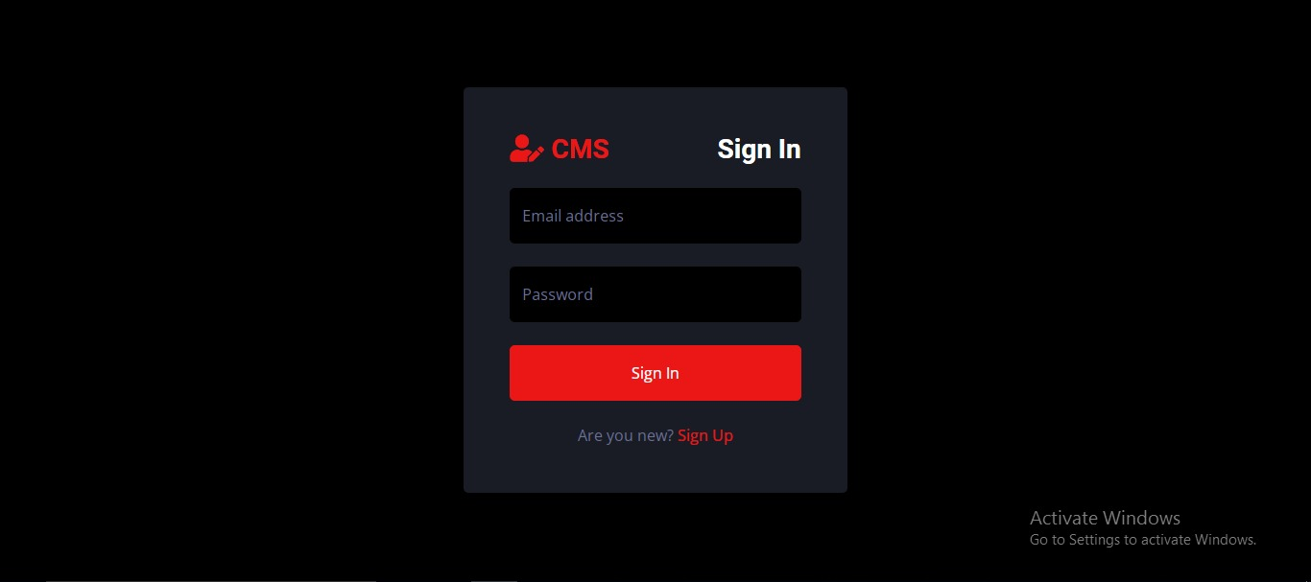

**Singup.php**

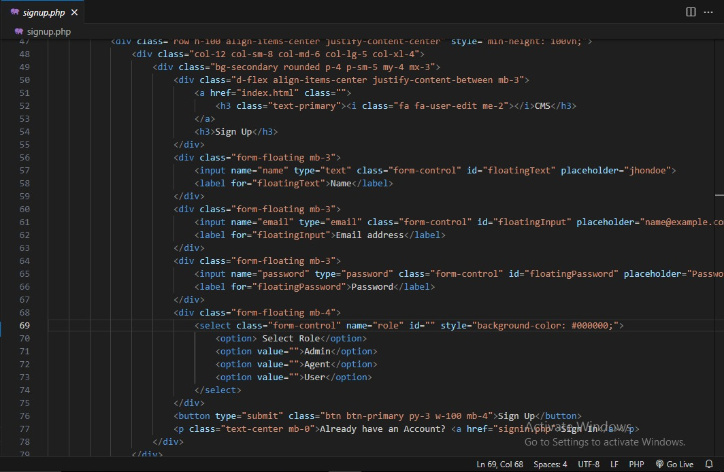

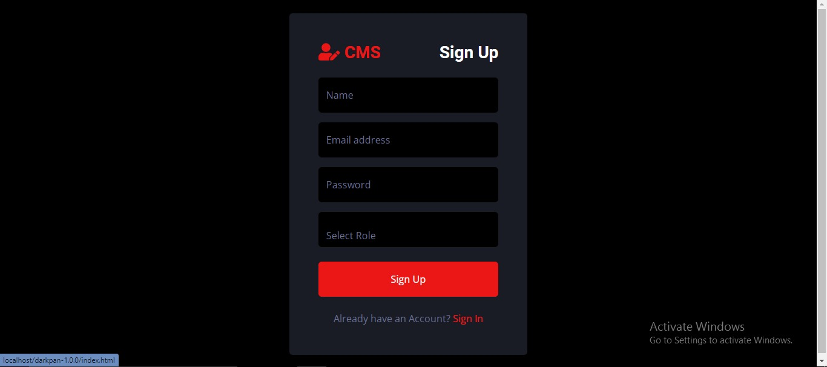

**Add courier.php**

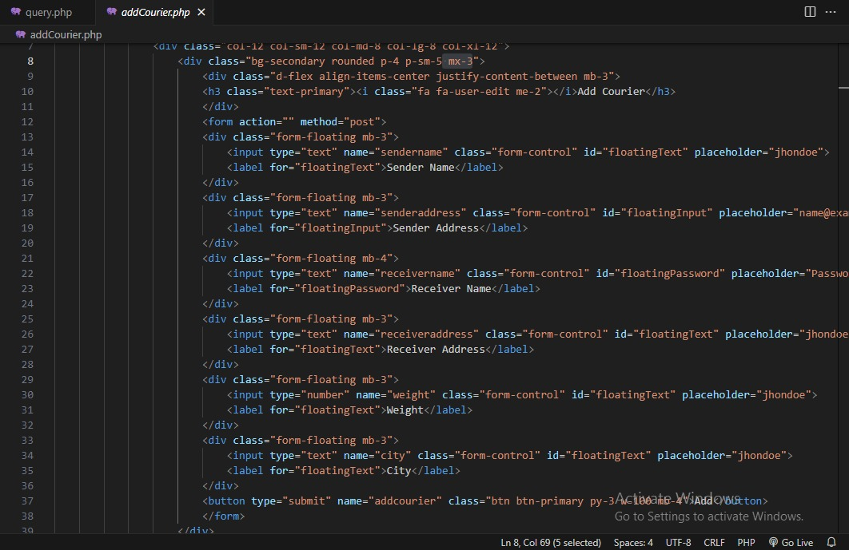

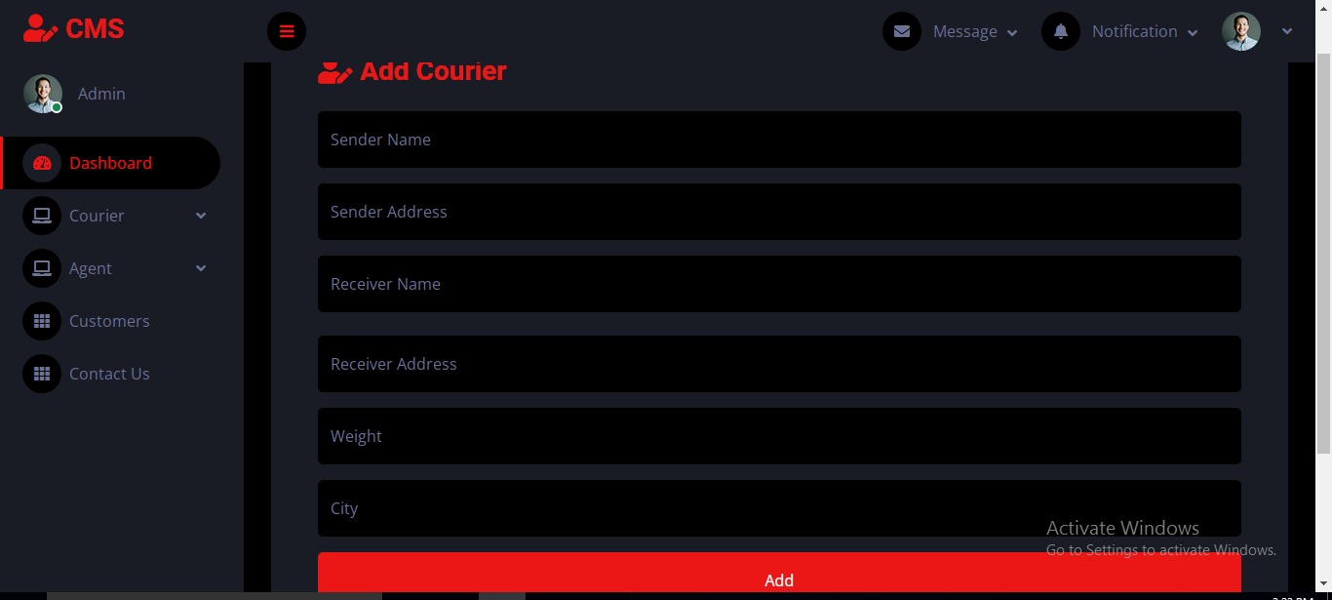

**Add Agent.php**

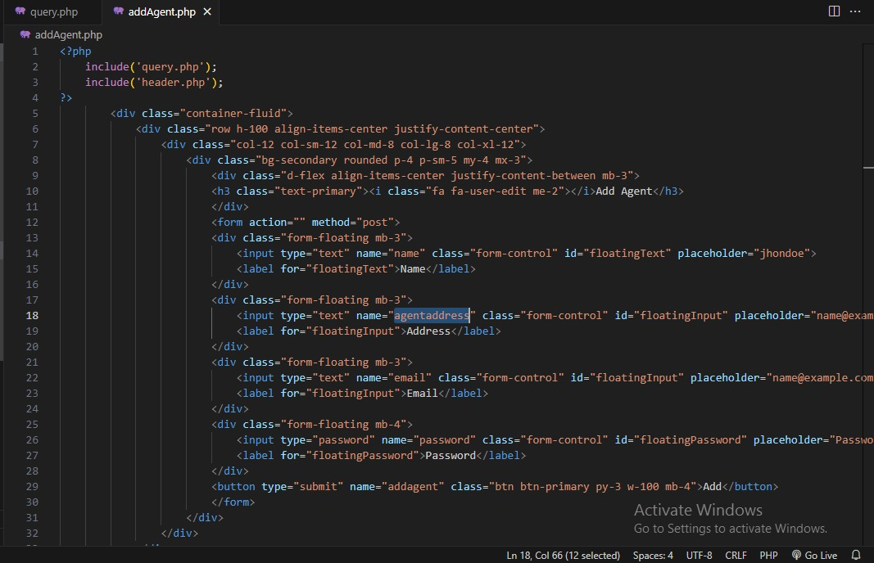

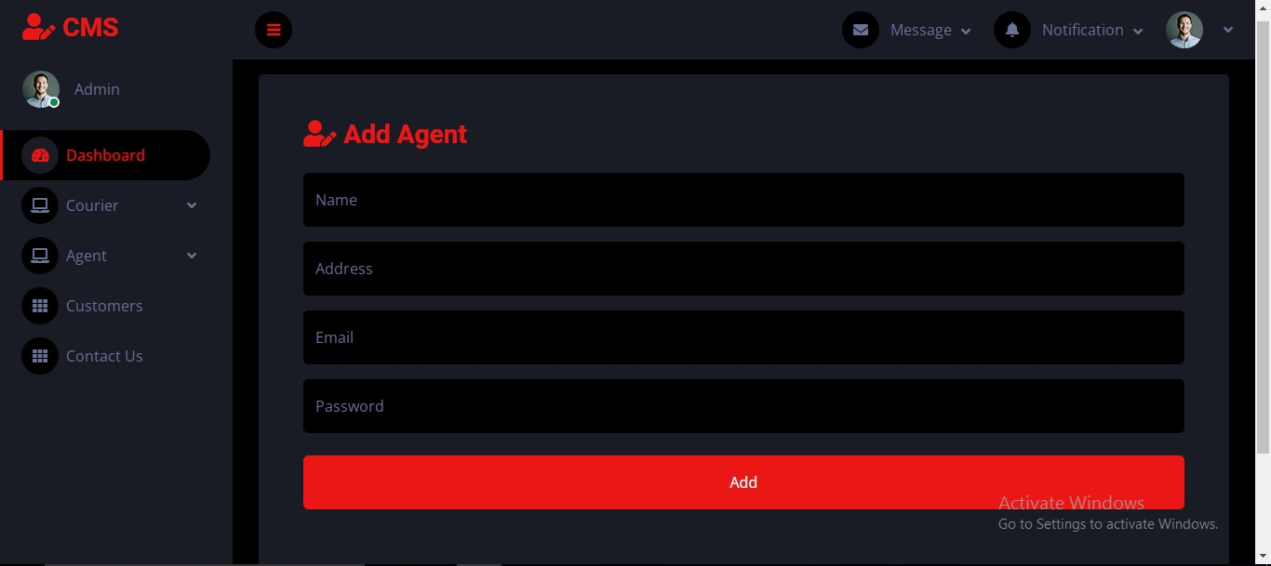

**View Couriers.php**

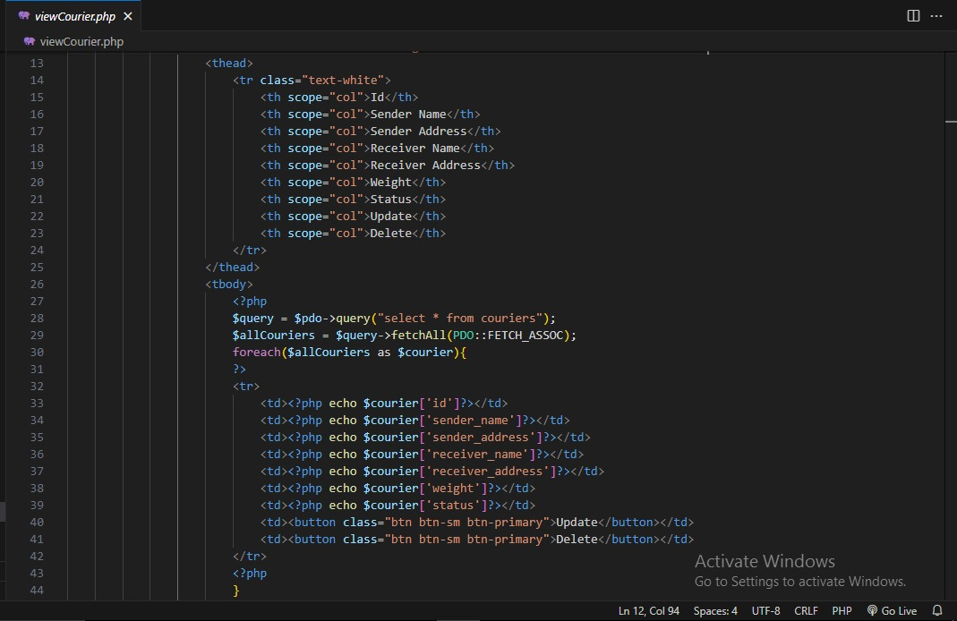

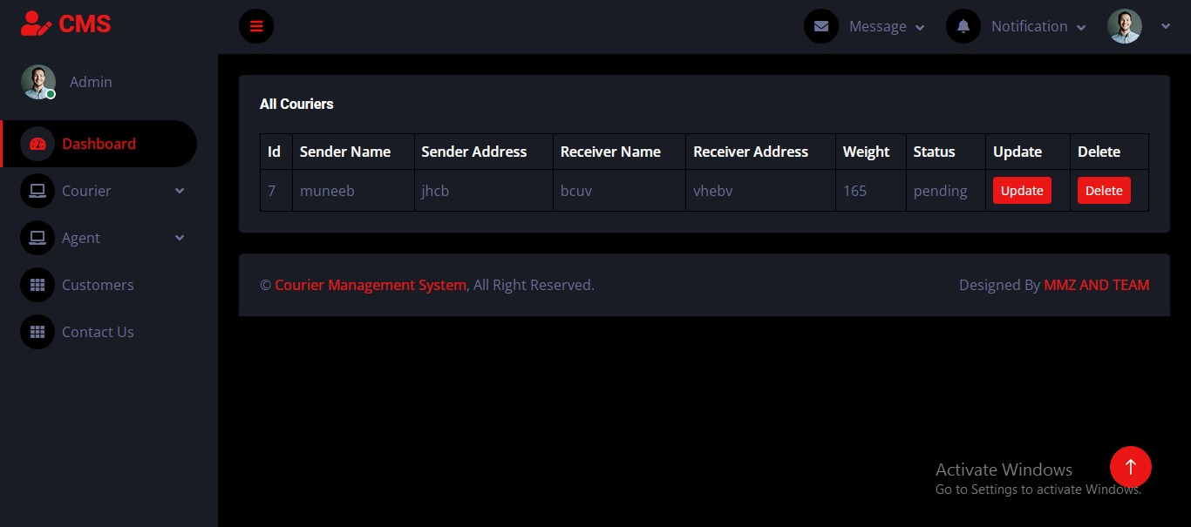

**View Agent.php**

